Inverse occlusion texturing for games, idea.

The goal of this was to see if it was possible to automate some of the harder edge cases of texturing. Recent jumps in finer levels of pelt mapping have made unrwapping easier but in games, short of Ndo there really isn't too many options. The scene below was textured by a process that I call inverse occlusion texturing. This works really well for prerendering. Using render to texture in 3ds max along with Vray, I was able to create this scene in a fairly quick amount of time. Around 30ish, hours.
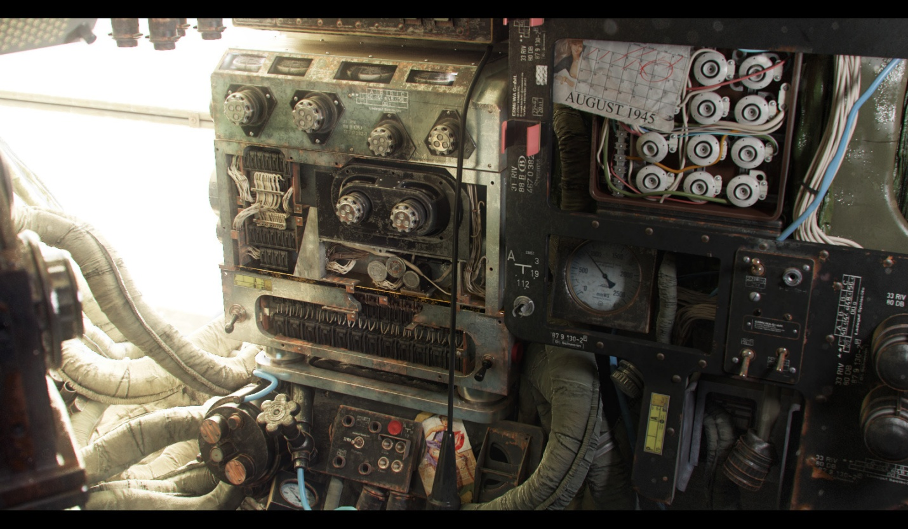
http://cghub.com/images/view/447957/
The idea is fairly simple, essentially instead of a standard occlusion look up (occlusion of one surface to another) Vray allows you to do the opposite check. To see edges that are not occluded. So you can get an edge mask. The goal is to try to speed up texturing and what not. I like to imagine a future where we are really spending our time on the hero stuff more so then well the not so hero stuff. I'm really into trying to find techniques that work great in pre-rendered and bring them into games.

So that's the general explanation so let's nerd out and get into the niddy gritty. This is something that comes standard with vray and its used heavily in arch viz renders. Most notibably the artist Alex Roman used this render technique for the third and seventh short he did. The vray dirt shader allows you inverse the occulsion calulation to essentially do an edge check on any object with a check box
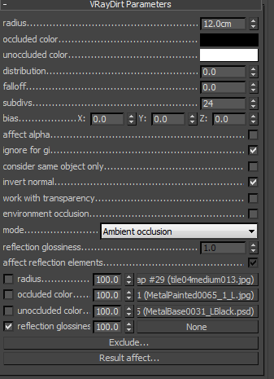

Here are some side tests using different shapes and what not.

Raw Diffuse OutPut
Comped Shader Output
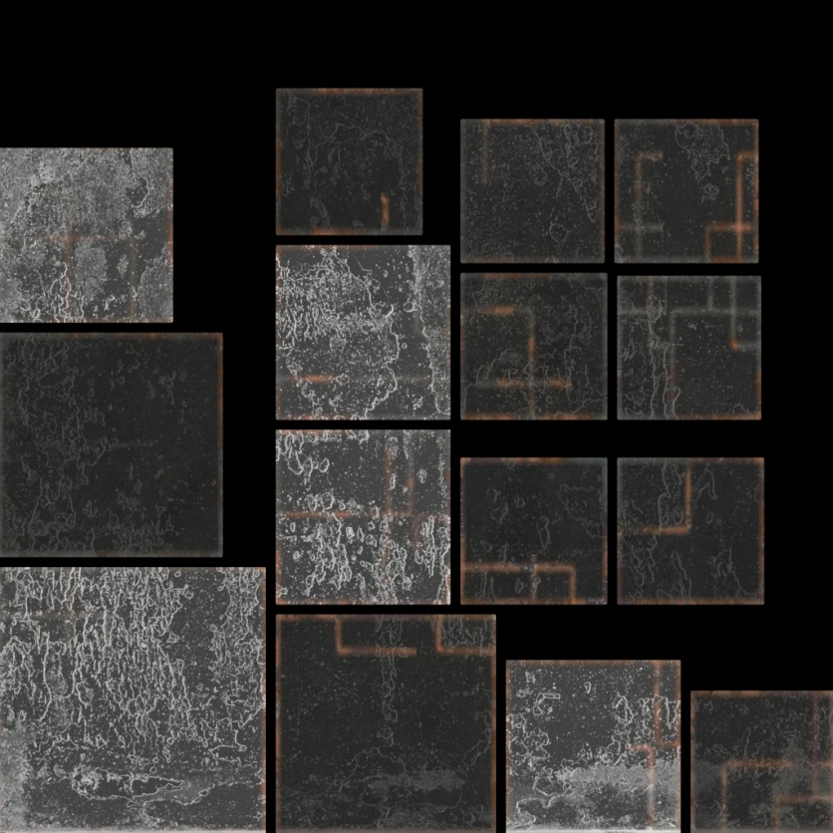http://www.3dtotal.com/index_gallery_detailed2.php?id=5460
Render Output
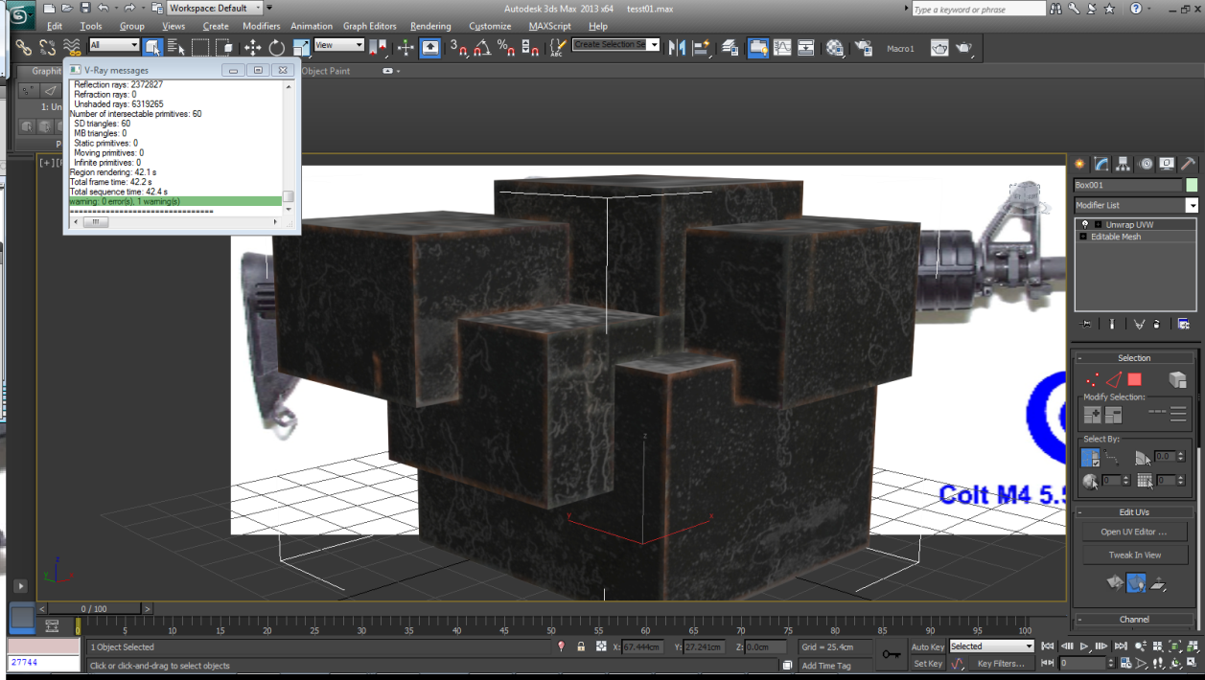
Same asset using a break up map to control the radius of the occulsion
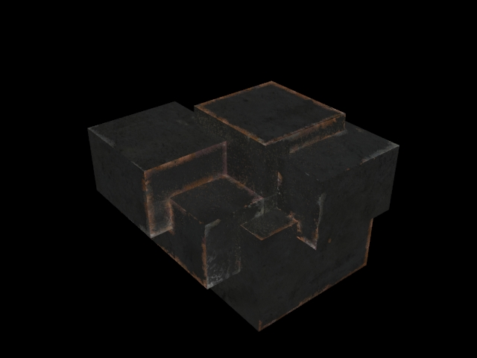

The cool thing about this is that it's a fast base for hero asset or if the lighting is solid it can just work. To be fair I've only done this in my personal work so I'm sure there are some areas where it fails. I'd really like to see if y'all think this worth looking into.
Here are some other applied assets. The occlusion in vray is scale dependent so one value doesn't work for all. To get around this all that is needed is a separate shader. The render to texture bakes out fine.
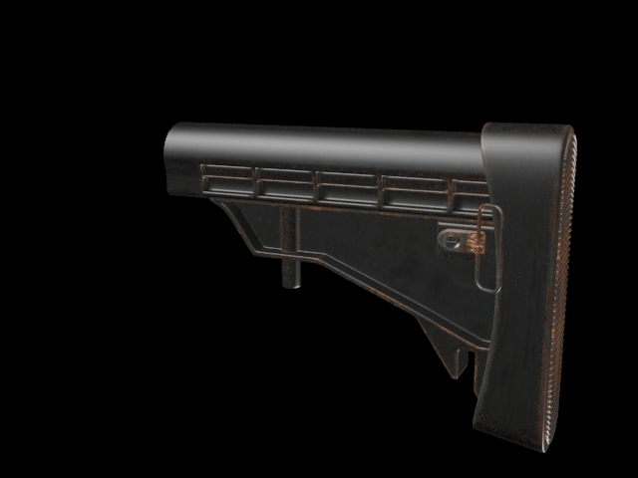
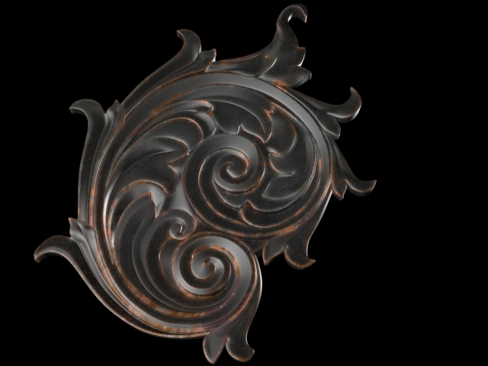
Applied to
A plane through render to texture, and the raw diffuse output
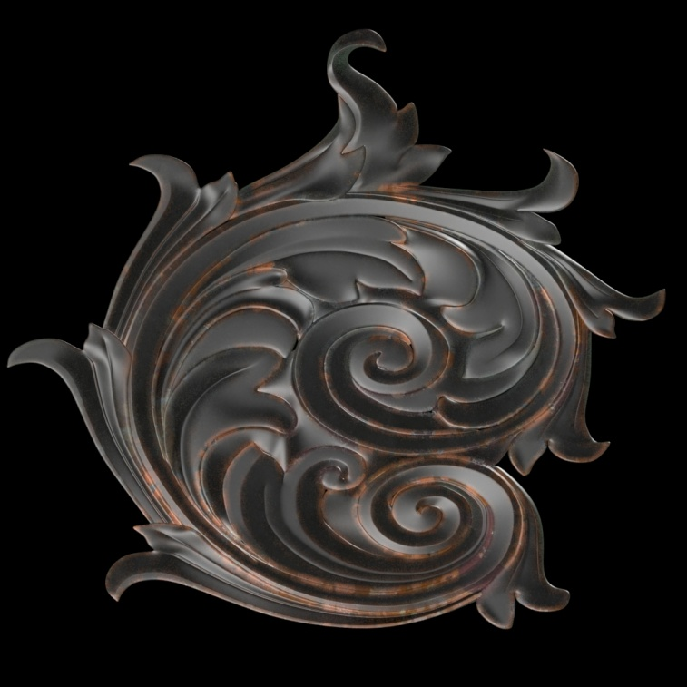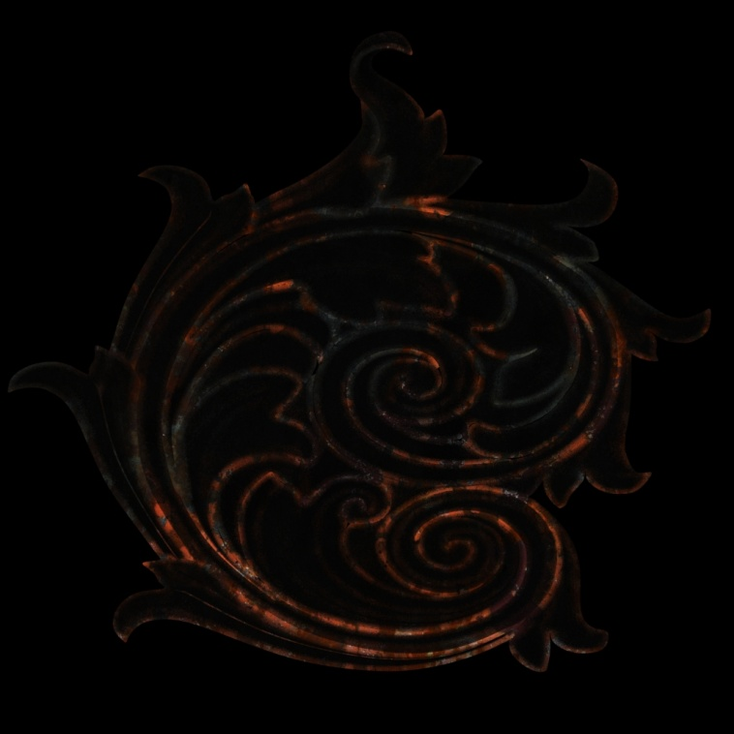
Here is the mask that be generated. This is prob the best use for this. 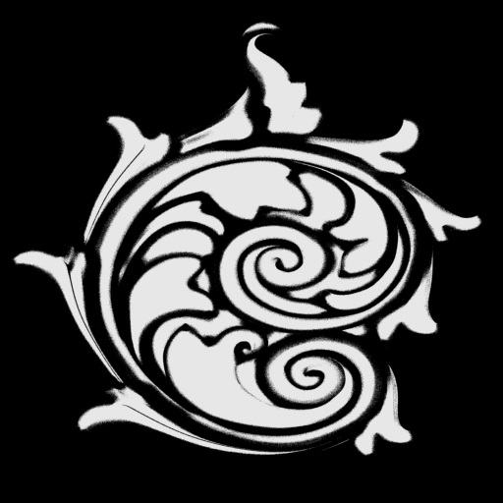
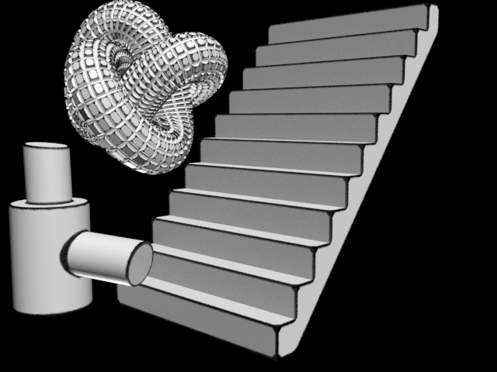

The other really cool thing is you have all of the benefits of using the max composite shader as well
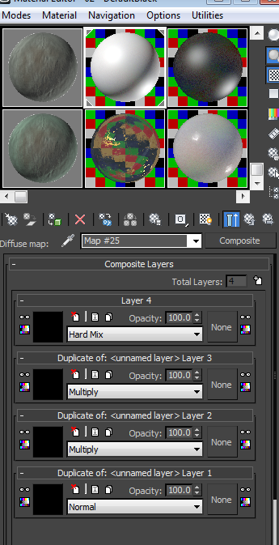
So in closing if you guys feel that this could warrant some time I would love to explore this more and test it on some existing assets. This was a super fast overview of how this works but its actually pretty easy to do and alot of fun once it's up and going
Thanks

Dave

